Applying for a State of Michigan Controlled Substance License

Register for an account

If this is the first time you’re using the State of Michigan (SOM) MiPlus system, you will have to register for a new account.

Link: Instructions from the SOM
Important reminders:
- Register as an individual

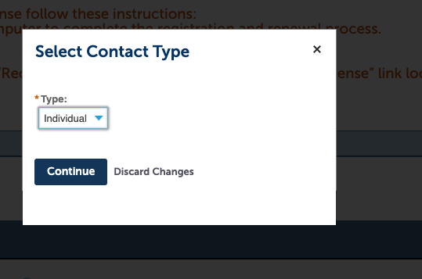

- You can now enter your mailing address (as separate from your drug storage address).

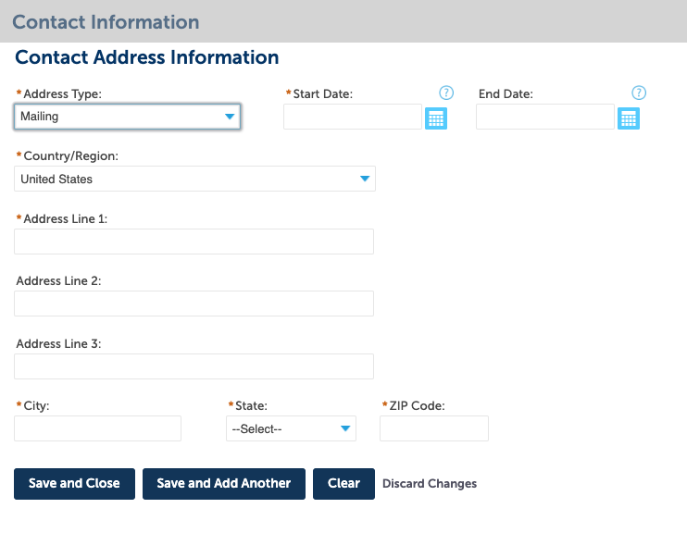
Apply for your license

Link: Generic instructions from the SOM
Important reminders:
- You will need to choose the type of license application you want. Choose:
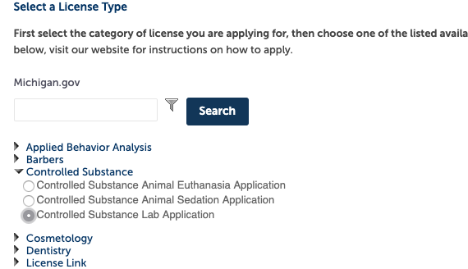

- You will then choose what type of controlled substance research license you need. This depends on which drugs you plan to use and for what research purpose:
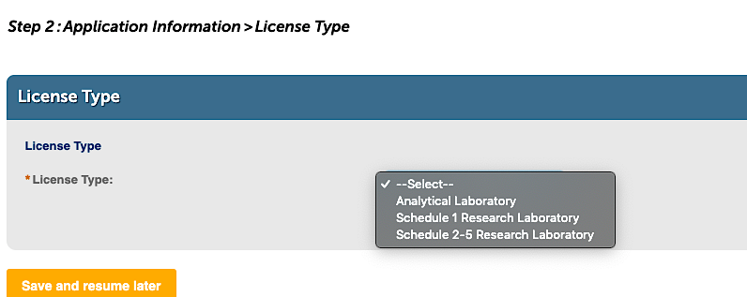

Example:
- Analytical Laboratory-Can use schedule 1-5 controlled drugs. Cannot administer to animals or humans.
- Schedule I Research Laboratory-Can use schedule 1 drugs only. May administer to animals and/or humans.
- Schedule 2-5 Research Laboratory-Can use schedule 2-5 drugs only. May administer to animals and/or use in vitro.
- In the attachment section (see below) you will need to attach, as separate documents, the following information. Use these as your examples:

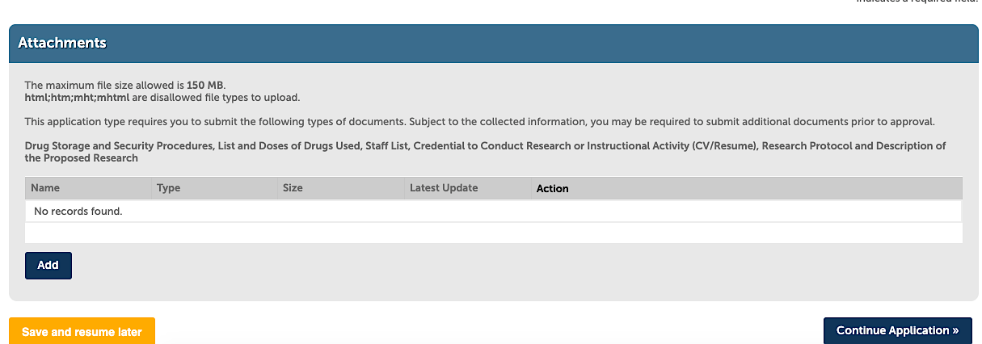

- Drug Storage and Security Procedures:
(Type of storage, where CS will be stored, if lab doors will be locked...)
Controlled substances will be stored in room 1234 of Medical Science Building I
(MS I). The controlled substances will be stored separately from all other drugs and materials in a combination safe bolted to the wall. The door to room 1234 and the door to the outer laboratory area are locked after-hours and when unattended. The U-M Department of Public Safety and Security (UMDPSS) are available 24/7 and are routinely in the area.

The controlled substances will only be handled by authorized personnel and taken out of the safe when they are needed for an experiment. All required invoices, inventories, use logs, disposal forms, etc. will be filed to maintain proper chain of custody.

- List and Doses of Drugs Used:
(Name and concentration, type of container and size, # needed/year, patient dose, patient type and how many/year):
- Ketamine 100 mg/ml, 5 ml vial, x5 vials/year, 0.05mg/kg, 100 mice/year
- Buprenorphine 0.3 mg/ml, 1 ml vial, x3 vials/year, 0.1mg/kg, 100 mice/year
- Pentobarbital 360 mg/ml, 250 ml vial, x1 vial/year, 0.5mg/kg, 100 mice/year

- Staff List:
(Name, title)
- Meredith Grey, General Surgery Resident
- Jon Snow, Night Watch Lab Technician
- Joyce Byers, Graduate Student

- Protocol of the Proposed Research:
Include it as a separate document. Do not include any proprietary information.
- CV
Include it as a separate document.

Contact the CS Monitors if you have questions!
CS-monitors@med.umich.edu

